How to Clock In & Out — UKG Ready Upgrade
First punch: Saturday, September 12

1. Download the UKG Ready App  Search “UKG Ready” on the App Store or Google Play, or scan the QR codes →  2. Log in  - Enter Company Information: Company short name: 26103SUN  - Username: first.last + last 5 digits of SSN  - Temp password: emailed Tue, Sept 8 from noreply@saashr.com  - Enable Location Services  3. Clock in / out for shifts and lunch  Open the app and punch in/out at the start and end of your shift, and for lunch.  4. No smartphone? iPads are available.  Backup iPads are at all timeclock locations. Use your current badge number to clock in.  5. A note on location  The app confirms you're on-site before it lets you punch. Check GPS is on if a punch won't go through. | SCAN TO DOWNLOAD  💰 PAYCHECKS WILL STAY THE SAME!  First paycheck under the upgrade: Fri, Oct 2  NEED HELP?  Your manager, or Talent Service Center:  623-471-8444 or TSC@sunhealth.org
  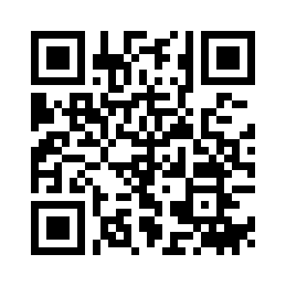  iPhone | 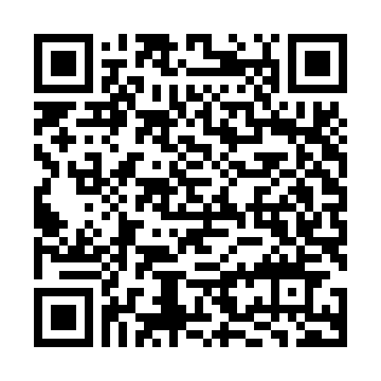  Android

Need Help?  Ask your manager, or call the Talent Service Center at 623-471-8444 or TSC@sunhealth.org | App or iPad clock not working?  Tell your manager right away.

Questions any time: Talent Service Center · 623-471-8444

